**CREATING AN INSTANCE IN THE VPC**

Create a key with any name (i.e mykeypair)

Run the command in the terminal

**Ssh-keygen –f mykeypair**

One public and one private will get create by the name of mykeypair.pub and mykeypair

**Instance.tf**

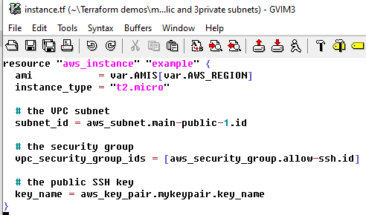

**Key.tf**

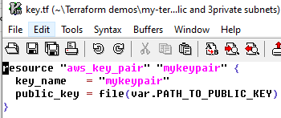

**Provider.tf**

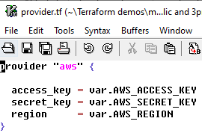

**Securitygroup.tf**

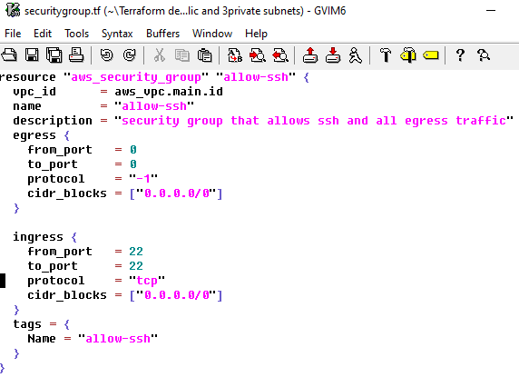

**Vars.tf**

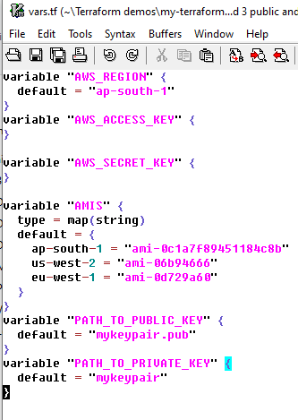

**Terraform.tfvars**

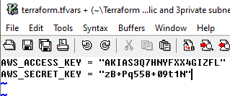

**Vpc.tf**

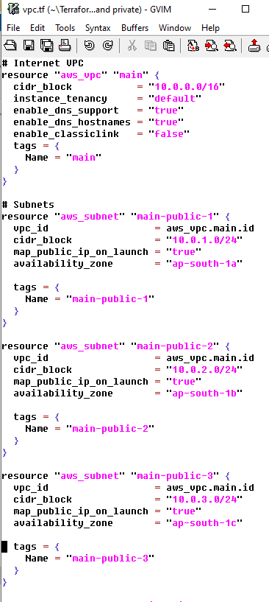

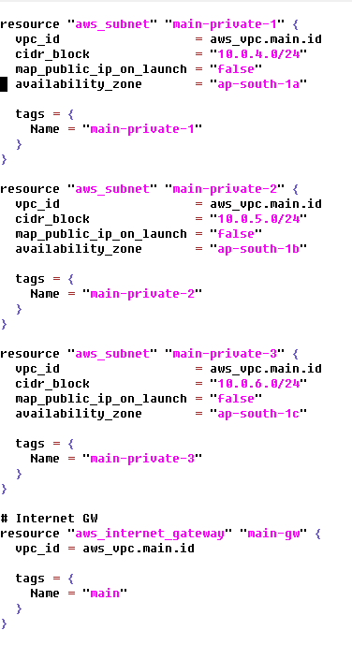

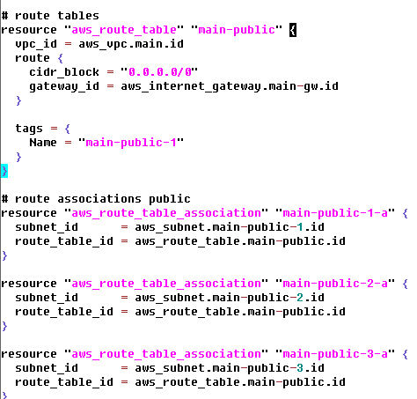

Run **terraform plan** commandto plan the execution

Then run **Terraform apply** command to execute the plan